The Relational Data Model
(Based on Chapter 5 & 6 in
Fundamentals of Database Systems by Elmasri and Navathe, Ed. 5)
1 Relational Model Concepts
2 Characteristics of Relations
3 Relational Integrity Constraints
3.1 Key Constraints
3.2 Entity Integrity Constraints
3.3 Referential Integrity Constraints
4 Update Operations on Relations
5 Relational Algebra (RA) Operations
5.1 SELECT σ and PROJECT Π
5.2 Set Operations
5.3 JOIN Operations
5.4 Additional Relational Operations

Languages (RA/SQL) and models (Relational DB) are sophisticated runtimes. Illustrate implementation/runtime issues with Oracle environment.

- Relational constraints and their processing
(Query updates must preserve DB consistency)
2. Query processing
a. RA origins of SQL
b. SQL and RA
(Many language issues – complex queries must be optimized)
- Concurrency – intro to Oracle “Read Consistency model”
Ex: WHO sees WHAT as user U adds a new row to table t:
INSERT INTO t
VALUES ( a , … , z );
(DB servers must support complex interactions of many users on extremely large DBs)
1. Relational Model Concepts

BASIS OF THE MODEL

• The relational Model of Data is based on the concept of a Relation.

• A Relation is a mathematical concept based on sets.

• The success of the relational approach due to formal foundation provided by the theory of relations
- data structures (lists, queues, etc) provide model and representation techniques for programmers
- the relational model ties together data representations in schemas, views, tables, columns with SQL, a well-matched language
__________________________________________________________
Prior to commercially available relational systems, large-scale DBMS already seen 15-years of vendor products. Most notable were:
  - IBM’s IMS a Hierarchical DBMS Model– first version used in the Lunar Lander project; data model = nary trees of segments
  - Other computer vendor offerings in the Network DBMS Model; data model = directed graphs
---------------------------------------------------------------------
In both of above models, appl. programming query code was “record-at-a-time-processing” (means: one query, <= one result record), as in:

Ex: /* Typical appl. Logic – Models used current position in DB in query semantics */
:
Job setup directives, specifying AMs, buffering, DB_Name and other run parameters
:
Following code pattern illustrates retrieving all dependent records of some parent:
FindFirst(RecordType, RecordBuffer, Status);) /* Position to first record we want */
/* Loop for retrieving all records in group we want, assuming FindFirst was successful */
WHILE (Status=found) DO
Get(RecordType, RecordBuffer, Status); /* Retrieve FindFirst result record */
: -- Error checking, followed by processing code, including record locking and tp code
FindNext(RecordType) /* Position to next record of RecordType */
ENDWHILE
-- Equivalent SQL query: get all dependents of employee with SSN 123456789
-- Instead of 10-15 LOC and necessary physical storage knowledge, one LOC !!!
-- Also, the 3GL control structures: loops and IFs are eliminated
SELECT firstname, dirthdate FROM dependents WHERE essn = ‘123456789’;

Relational SQL simplifies above 3GL style of DB programming via:
- “set-at-a-time processing” (SELECT can return any number of rows)
- No “navigation” code as in FindFirst, WHILE, Get, and FindNext
- Physical details hidden (Little reference to AM, buffering, search steps etc.)

The relational model was first proposed by Dr. E.F. Codd of IBM in 1970 in the following paper - "A Relational Model for Large Shared Data Banks," Communications of the ACM, June 1970.

INFORMAL DEFINITIONS

• RELATION: A table of values

• A relation may be thought of as a set of rows.

• A relation may alternately be though of as a set of columns.

• Each row of the relation may be given an identifier.

• Each column typically is referenced by its column name –
referencing table information in any other way is illegal
There are:
- no pointers
- no context wherein the next query result depends on position or context of previous query

FORMAL DEFINITIONS

• A Relation may be defined in multiple ways.
• The Schema of a Relation:
R (A1, A2, .....An)
R is the relation name, and relation R is defined over attributes A1, A2, .....An
For Example -
CUSTOMER (Cust-id, Cust-name, Address, Phone#)

Here, CUSTOMER is a relation defined over the four attributes Cust-id, Cust_name, Address, Phone#, each of which has a domain = (set of valid data types and values). For example, the domain of Cust-id could be: 6 digit numbers.
• A tuple is an ordered set of values
• Each value is derived from an appropriate domain.
• Each row in the CUSTOMER table may be accessed as a tuple in the table and would consist of four values.
<632895, ‘John Smith’, ‘101 Main St. Atlanta, GA 30332’, ‘(404) 894-2000’> is a triple belonging to the CUSTOMER relation.
• A relation may be regarded as a set of tuples/rows.
• Columns in a table are also called as attributes of the relation.

FORMAL DEFINITIONS (contd.)

• The relation is formed over the cartesian product of the sets; each set has values from a domain; that domain is used with a specific meaning which is conveyed by the attribute name.

• For example, attribute Cust-name is defined over the domain of strings of 25 characters. The role these strings play in the CUSTOMER relation is that of the name of customers.

• Formally,
Given R(A1, A2, .........., An)
r(R) subset-of dom (A1) X dom (A2) X ....X dom(An)

R: schema of the relation
r of R: a specific "value" of R, consisting of “n tuples”, aka n rows
• R is also called the intension of a relation
r is also called the extension of a relation

Recall relation notation from discrete math:

Let S1 = {0,1}
Let S2 = {a,b,c}

Let R subset-of S1 X S2

for example: r(R) = {<0,a> , <0,b> , <1,c> } is a subset of S1 X S2

DEFINITION SUMMARY

Informal Terms Formal Terms

Table Relation
Column Attribute/Domain
Row Tuple
Values in a column Domain
Table schema/definition Schema of Relation
Populated Table Extension

Relational Algebra (RA) is formal basis for relational query languages
RA defines what operators are defined on relations and defines the
result of applying such operators

SQL is a “declarative”/”functional” language – each (for example, SQL SELECT) query Q specifies WHAT user wants to retrieve, but does NOT SPECIFY HOW TO FIND IT OR WHAT AMs TO USE

EACH RELATIONAL IMPLEMENTATION (SUCH AS Oracle) AUTOMATICALLY DOES THE SEARCHING + AMs + SORTING, AS EACH QUERY IS PROCESSED

Thus SQL is much easier to use than legacy DBMS query languages
that need programming expertise;
Many who are not professional programmers can be trained for effective use of elementary SQL

In practice:

SQL and RA have Shortcomings/Limitations (more later) as well as
their power and simplicity

RA

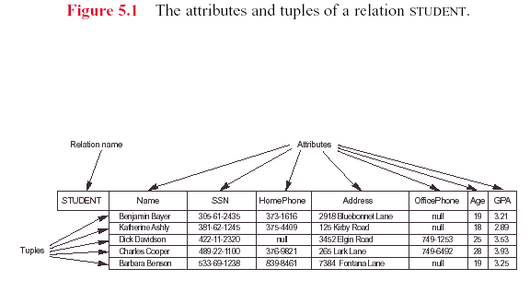

2 Characteristics of Relations

Ordering of tuples in a relation r(R): The tuples are not considered to be ordered, even though they appear to be in the tabular form.

Ordering of attributes in a relation schema R (and of values within each tuple): We will consider the attributes in R(A1, A2, ..., An) and the values in t=<v1, v2, ..., vn> to be ordered .

Values in a tuple: All values are considered atomic (indivisible). A special null value is used for values that are unknown or inapplicable to some tuples.
Note: atomic column value means that relational does NOT allow overloading (more than one meaning) per column value

Notation:
- We refer to component values of a tuple t by t[Ai] = vi (the value of attribute Ai for tuple t).
Similarly, t[Au, Av, ..., Aw] refers to the subtuple of t containing the values of attributes Au, Av, ..., Aw, respectively.

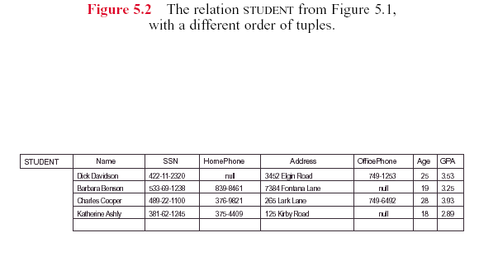

3 Relational Integrities/Constraints

Constraints are conditions that must hold on all valid relation instances. There are three main types of constraints:
1) Key integrity, 2) Entity integrity, and 3) Referential Integrity (RI)

3.1 Key Constraints
Key integrity - Each relation should have a specified (primary) key (PK)
Superkey of R: A set of attributes SK of R such that no two tuples in any valid relation instance r(R) will have the same value for SK. That is, for any distinct tuples t1 and t2 in r(R), t1[SK] <> t2[SK].
Key of R: A "minimal" superkey; that is, a superkey K such that removal of any attribute from K results in a set of attributes that is not a superkey.

Example: The CAR relation schema:
CAR(State, Reg#, SerialNo, Make, Model, Year) ←SerialNo assumed unique
has two keys Key1 = {State, Reg#}, Key2 = {SerialNo}, which are also superkeys. {SerialNo, Make} is a superkey but not a key (Make is not needed).

If a relation has several candidate keys, one is chosen, based on “pragmatics”
(such as: least storage space, most-meaningful key to users, etc.)
to be the primary key. Relation schema primary key attributes are underlined.

Often, in applications, a surrogate key must be used – because a relation does not have a superkey that would be both unique and useable
Ex: Oracle sequence objects, whose values are successive positive integers

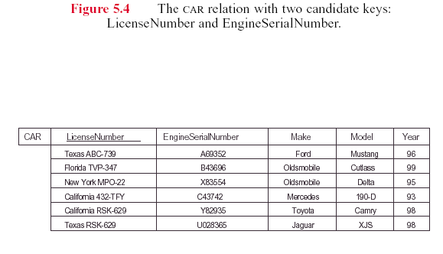

3.2 Entity Integrity constraint

Relational Database Schema: A set S of relation schemas that belong to the same database. S is the name of the database. S = {R1, R2, ..., Rn}
In your Oracle student environment, all of the relations/tables you own are a schema with the same name as your Oracle username. You will not need to refer to a database name as you use SQL and other Oracle facilities.

Entity Integrity - The primary key attributes PK of each relation schema R in S cannot have null values in any tuple of r(R). This is because primary key values are used to identify the individual tuples.
No column value of: t[PK] can be null for any tuple t in r(R)

Note: Other (non-key) attributes of R may be similarly constrained to disallow null values, and also to enforce unique values
Ex: Each EMPLOYEE must provide a home/cell phone# in employee record

Issue (more detail later): null values are problematical in relational DBs:
- Complicate SQL language for dealing with them
- Cause problems with operations involving related DB rows
.
-- Each Oracle table definition should always have a primary key constraint:
CREATE table TableName (PK_ColumName ColumnType,
:
Last_ColumnName ColumnType )
constraint PK_constraint primary key(PK_ColumName )
3.3 Referential Integrity

A constraint involving two relations: Specifies a relationship among tuples in the referencing relation and the referenced relation.
Tuples in referencing relation R1 have attributes FK (called foreign key (FK) attributes) that reference the primary key attributes PK of the referenced relation R2. A tuple t1 in R1 is said to reference a tuple t2 in R2 if t1[FK] = t2[PK].

A referential integrity constraint can be displayed in a relational database schema as a directed arc from R1.FK to R2 (See: Fig 5.7, p. 139).

Referential Integrity – for each FK value “v” in referencing relation R1
- v is null OR
- v is not null, and, there must exist a row in the referenced relation R2 whose row PK value “kv” equals v

Ex: SHIPMENT row ( … , supplier#, part#, … ) and row “sh_row” (R1)
PART( … , p#, color, manufacturer, … ) and row “p_row” (R2)

sh_row( …, supplier#, v , … )

:
p_row( …, kv , … )
:
Note: RIs can exist between a relation and itself (R2 same as R1 above)
Ex: one employee can manage other employees

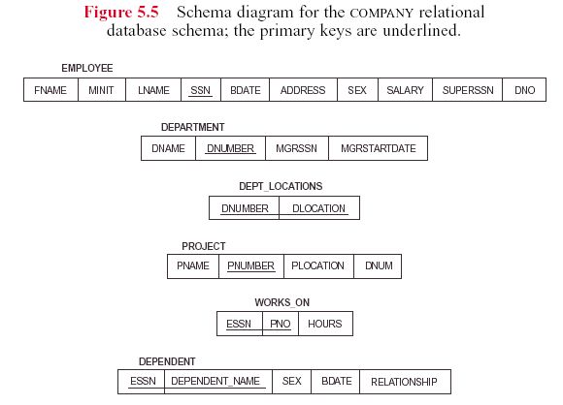

Note: We will use informal notations of single underlining for PK and double underlining for FK columns in external and conceptual schema diagrams

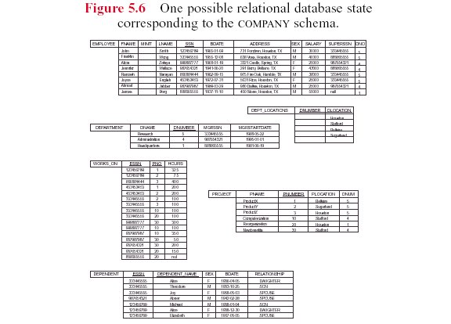
We will refer very frequently to this snapshot of the COMPANY database (pg. 159) throughout the semester. Although it is a small data set, it illustrates many issues involving proper relational schema construction.

Whenever you create and populate a relational schema, you want the 3 relational model integrity rules to be automatically enforced. The only way to ensure this is to define PK and FK constraints at table creation time.

A relational database is not a data dump → observe the integrities to gain the full benefit and proper use of relational systems !
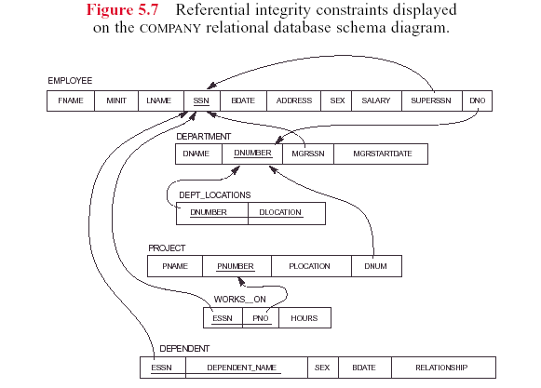
The directed arrows point FROM the FK column(s) TO the PK column(s)

Complex queries/updates on huge tables strain even the most powerful modern servers

The chart below displays a combination of (mostly) Oracle and a minor amount of OS processing of various categories (coded by color) to execute a query
3 tables, 2 of the tables having many millions of rows (approx 5GB data)
Dominant operations: 1. read tables [light blue] 2. temp storage of intermediate results [dark blue] 3. CPU processing/sorting [green] 4. DBMS tp overhead [brown]
Total query duration: 62 minutes = optimization of original 88 minutes elapsed
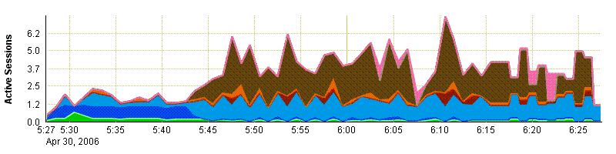
4 Update Operations on Relations

- INSERT a tuple (into a relation)
- DELETE a tuple (that currently exists in a relation).
- MODIFY a tuple (that currently exists in a relation)

- Integrity constraints must not be violated by the update operations.
- Several update operations may have to be grouped together.
- Updates may propagate to cause other updates automatically. This may be necessary to maintain integrity constraints.

Ex: In COMPANY DB, suppose that Department “5” is abolished/eliminated;
Immediate consequence is that each row in all tables with an FK referencing dnumber 5 must be updated to new dno values, or else set to null
Examples such as these show the large (internal and invisible to users) cost of enforcing RI, as well as other relational model constraints.
The first relational product vendors ( in early 1980s) struggled to deliver systems that had acceptable performance for real-world application demands

- In case of integrity violation, several actions can be taken:
- cancel the query/queries that caused the violation (REJECT option) - safe
- perform the operation but inform the user of the violation - unsafe
- trigger additional updates so the violation is corrected (CASCADE option, SET NULL option) - safe
- execute a user-specified error-correction routine – safe
(Each of the safe options can be automated)
5 The Relational Algebra (RA) operators

- Operations to manipulate relations.
- Query result is in the form of a relation

Relational Operations:
5.1 SELECT σ and PROJECT Π operations.
5.2 Set operations: These include UNION U, INTERSECTION | |, DIFFERENCE -, CARTESIAN PRODUCT X.
5.3 JOIN operations X.
5.4 Other relational operations: DIVISION, OUTER JOIN, AGGREGATE FUNCTIONS, not originally in RA

5.1 SELECT σ and PROJECT Π

First 2 operations do the obvious: extract subsets of rows/columns from R
SELECT operation (denoted byσ ):
- Selects/gathers the tuples (rows) from one relation R that satisfy a certain selection condition c
- Form of the operation: σ c(R)
- The condition c is an arbitrary Boolean expression on the attributes of R

- Resulting relation has the same attributes as R
- Resulting relation includes each tuple in R whose attribute values satisfy c

Examples:
σ DNO=4(EMPLOYEE)
σ SALARY>30000(EMPLOYEE)
σ(DNO=4 AND SALARY>30000) OR DNO=5 (EMPLOYEE)
(Within each c, parentheses specify order of evaluation)

PROJECT operation (denoted byΠ ):

- Keeps only specified attributes (columns) from a relation R specified in an attribute list L
- Form of operation: Π L(R)
- Resulting relation has only those attributes of R specified in L

Example: Π FNAME,LNAME,SALARY(EMPLOYEE)

- The PROJECT operation eliminates duplicate tuples in the resulting relation so that it remains a mathematical set (no duplicate elements)
Example: Π SEX,SALARY(EMPLOYEE)
If several male employees have salary 30000, only a single tuple <M, 30000> is kept in the resulting relation.

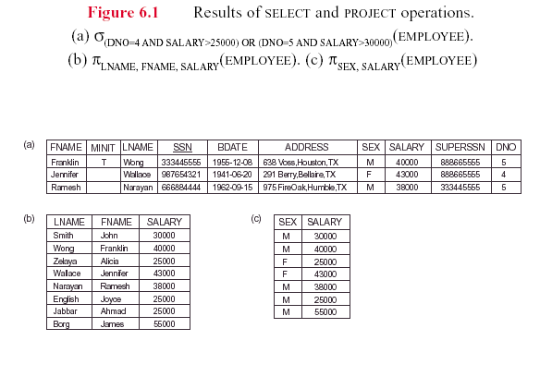

Sequences of operations:

- Combining operations gives a relational algebra expression (aka query)
Example: Retrieve names and salaries of employees who work in department 4:
Π FNAME,LNAME,SALARY ( σ DNO=4(EMPLOYEE) )
Read/Interpret above query as function composition, thus
- apply σ yielding an intermediate (to be discarded) relation
- apply Π to σ intermediate yielding the final result relation
- Alternatively, we specify explicit intermediate relations for each step:
DEPT4_EMPS ← σ DNO=4(EMPLOYEE)
R ← Π FNAME,LNAME,SALARY(DEPT4_EMPS)

- Attributes can optionally be renamed in the resulting left-hand-side relation (this may be required for some operations that will be presented later):
DEPT4_EMPS ←σ DNO=4(EMPLOYEE)
R(FIRSTNAME,LASTNAME,SALARY) ←
Π FNAME,LNAME,SALARY(DEPT4_EMPS)

See Fig 6.2 b), second figure, shows the rows of intermediate relation R of above (but called TEMP, as in textbook)

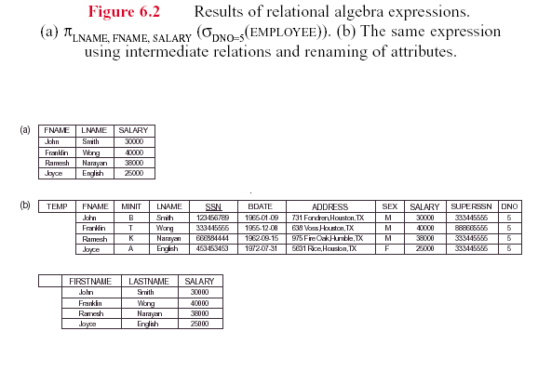

5.2 Set Operations

- Binary operations from mathematical set theory:
UNION: R1 U R2,
INTERSECTION: R1 | | R2,
SET DIFFERENCE: R1 - R2,
CARTESIAN PRODUCT: R1 X R2.

- For U, | |, -, the operand relations R1(A1, A2, ..., An) and R2(B1, B2, ..., Bn) must have the same number of attributes, and the domains of corresponding attributes must be compatible; that is, dom(Ai)=dom(Bi) for i=1, 2, ..., n. This condition is called union compatibility.
Note that Ai,Bi pairs can have different identifiers/names, but their data types and constraints must be the same

- For the X operator, there is no need for union compatibility

- By convention, the result relation for U, | |, or - has the same attribute names as the first operand relation R1

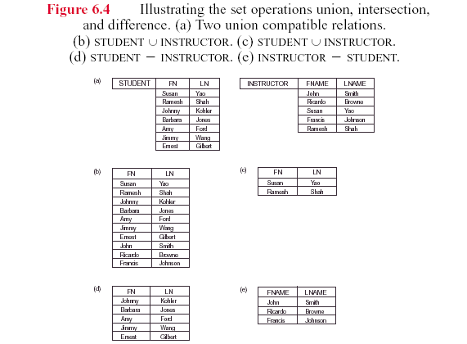
Result (c) is STUDENT INSTRUCTOR
CARTESIAN PRODUCT
R(A1, A2, ..., Am, B1, B2, ..., Bn) ←
R1(A1, A2, ..., Am) X R2 (B1, B2, ..., Bn)

- A tuple t exists in R for each combination of tuples t1 from R1 and t2 from R2 such that: t[A1, A2, ..., Am]=t1 and t[B1, B2, ..., Bn]=t2
- If R1 has n1 tuples and R2 has n2 tuples, then R1 X R2 has n1* n2 tuples.
(X computation has potentially HUGE results, even for modest sized R1,R2)

- CARTESIAN PRODUCT is a meaningless operation on its own in most applications. It can usefully combine related tuples from two relations when followed by the appropriate SELECT operation
Example: Combine each DEPARTMENT tuple with the EMPLOYEE tuple of the manager.
DEP_EMP ← DEPARTMENT X EMPLOYEE
DEPT_MANAGER ← σ MGRSSN=SSN(DEP_EMP)

Using the COMPANY DB snapshot content of p. 159, and abbreviating EMPLOYEE and DEPARTMENT as E and D,
- |E| = ? rows, |D| = ? rows: Ans: 8 rows and 3 rows respectively
- D X E has 24 rows
For each D row, there is only one E row satisfying MGRSSN = SSN
(because we have implicit assumption, i.e., not stated in textbook, of 1 manager per department)
Thus, DEPT_MANAGER result relation has 3 rows, each row consisting of concatenation of a D row with (the 1 of 8 E rows that is the employee managing that department).
For a given row of D, MGRSSN=SSN selects the specific row of E
5.3 JOIN Operations

Introduce Xc operator to select (on = and other ops ) and concatenate rows from R1, R2 using one operator, rather than X followed by σ.

THETA JOIN: Similar to a CARTESIAN PRODUCT followed by a SELECT The condition “c” is called a join condition.
R(A1, A2, ..., Am, B1, B2, ..., Bn) ←
R1(A1, A2, ..., Am) X c R2 (B1, B2, ..., Bn)
Ex: simple abstract example: Assume Ai and Bj are operation compatible (say, integer attributes); then condition c could be: Ai > Bj
Result would be: All rows ra concatenate rb, where ra is a row of R1, rb is a row of R2 such that ra.Ai > rb.Bj Ex: assume A2, B1 type int; “|” is concatenation.
R1 A1 A2 R2 B1 B2 B3 The 6 result rows for R1.A2 > R2.B1 are:
r11 3 5 r21 3 6 -2 r11 | r21, r11 | r22, r11 | r23,
r12 7 0 r22 3 4 5 r13 | r21, r13 | r22, r13 | r23
r13 9 9 r23 2 0 8 rij denotes relation i row j: Note: r12 does not participate in this “> join”

EQUIJOIN: The join condition c includes one or more equality comparisons (only) involving attributes from R1 and R2. That is, c is of the form:
(Ai=Bj) AND ... AND (Ah=Bk); 1<i,h<m, 1<j,k<n (Ak,Bk must be comparable)
In the above EQUIJOIN operation:
Ai, ..., Ah are the join attributes of R1; Bj, ..., Bk are the join attributes of R2
Example of using EQUIJOIN:
Retrieve each DEPARTMENT's name and its manager's name:
T ←DEPARTMENT X MGRSSN=SSN EMPLOYEE (T has 3 rows)
RESULT ←Π DNAME,FNAME,LNAME(T) (RESULT has 3 rows)
NATURAL JOIN (*) (aka JOIN):
In an EQUIJOIN R ← R1 X c R2, the join attribute of R2 appear redundantly in the result relation R. In a NATURAL JOIN, the redundant join attributes of R2 are eliminated from R. The equality condition is implied so is not specified .
R← ( R1 * (join attributes of R1),(join attributes of R2) R2 )
Example: Retrieve each EMPLOYEE's name and the name of the DEPARTMENT he/she works for:
T ← EMPLOYEE *(DNO),(DNUMBER) DEPARTMENT
RESULT ←Π FNAME,LNAME,DNAME(T)

If the join attributes have the same names in both relations, they need not be specified and we can write R ← R1 * R2.
Example: Retrieve each EMPLOYEE name and name of his/her SUPERVISOR
/* First, create fragment relation of: supervisor name and superssn join column */
SUPERVISOR(SUPERSSN,SFN,SLN) ← Π SSN,FNAME,LNAME(EMPLOYEE)
/* Then, do natural join of EMPLOYEE with “SUPERVISOR” fragment */
/* Doing so eliminates all EMPLOYEE | SUPERVISOR concatenations that */ /* do not match in the superssn column, thus for each employee finding */
/* the match; Ex: Smith’s SUPERSSN (333445555)matches Wong’s SSN */
/* so (John, Smith, Franklin, Wong) is a row of the solution T*/
T←EMPLOYEE * SUPERVISOR
(the * is the condition: EMPLOYEE.SUPERSSN = SUPERVISOR.SUPERSSN)
/* Project out the columns wanted in final result */
/* Note that SUPERVISOR.SUPERSSN is an SSN value of a (possible) supervisor */
RESULT ←Π FNAME,LNAME,SFN,SLN(T)

In Fig 6.7 (a), the * computes the controls relationship between PROJECT and DEPARTMENT (by the JOIN: DNUM = DNUMBER)

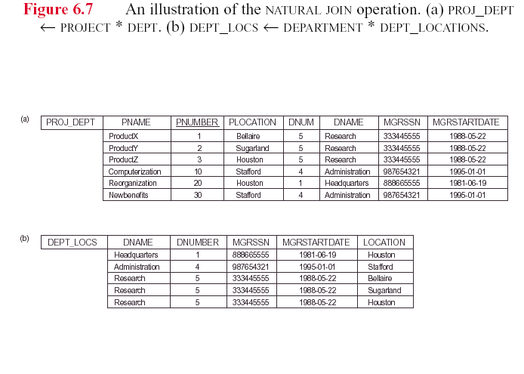

Note: In the original definition of NATURAL JOIN, the join attributes were required to have the same names in both relations. This attributes requirement no longer true.

There can be a more than one set of join attributes with a different meaning between the same two relations. For example:

JOIN ATTRIBUTES RELATIONSHIP
EMPLOYEE.SSN= EMPLOYEE manages
DEPARTMENT.MGRSSN the DEPARTMENT

EMPLOYEE.DNO= EMPLOYEE works for
DEPARTMENT.DNUMBER the DEPARTMENT
Thus, queries that compute relationships can correctly do so only if
the column meanings in the participating relationships are understood.

Relation R can have a set of join attributes to join R with itself :
As such, it is a recursive relationship;
Example:
JOIN ATTRIBUTES RELATIONSHIP
EMPLOYEE(1).SUPERSSN= EMPLOYEE(2) supervises
EMPLOYEE(2).SSN EMPLOYEE(1)

- One can think of this as joining two distinct copies of the relation, although only one relation physically exists
- In this case, renaming can be useful

Example: Retrieve each EMPLOYEE (first and last) name and the (first and last) name of his/her SUPERVISOR:
-- Get SSN and first+last name of employees into temp relation SUPERVISOR
SUPERVISOR(SSSN,SFN,SLN)←
Π SSN,FNAME,LNAME(EMPLOYEE)
-- Join EMPLOYEE and SUPERVISOR on condition:
-- EMPLOYEE SUPERSSN = SUPERVISOR SSN
T←EMPLOYEE X SUPERSSN=SSSN SUPERVISOR
RESULT ←Π FNAME,LNAME,SFN,SLN(T)

RA significance
Historical -- Codd used RA as core constructs of what evolved to SQL
Current -- Sophisticated DBMS query processors optimize queries (means minimize runtime using RA notations internally)
Although a good basis for relational query language, RA has been replaced by SQL. However, neither language is a general-purpose, as illustrated next. usage in SQL query optimization – an outline
I
Figure – ‘RA is Incomplete’
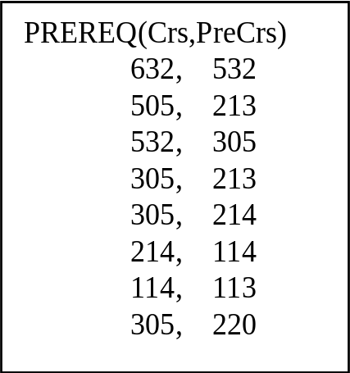

RA is incomplete – there are practical queries that are awkward to do
Example Q (in its English equivalent) that SQL is unable to express:
Given table PREREQ(Crs,PreCrs),
Q = “Is x a (once or twice or … removed) prerequisite for y”?

Answer sketch: Q is just another form of transitive closure
computation for binary relations (relation is: y is a prerequisite of x)
Right-side relations below have schema: Crs1,PreCrs1, Crs2, PreCrs2
T ←JOIN _{Crs2=PreCrs1} (PREREQ,PREREQ)
and TWICE_REMOVED ← Π_{Crs1,PreCrs2} (T) is first computation phase, and is the twice removed prerequisites of each course. One TWICE_REMOVED result row is obtained as follows:
632 532 532 305 via = JOIN
Crs1 PreCrs1 Crs2 PreCrs2 via Rename
632 305 via Π
Thus, (632 305) and (632 532) are in Π_{Crs,PreCrs} (T) U PREREQ =
the union of the twice removed and once removed prerequisites of courses.

The arrows show how one of the rows of T is formed via the JOIN. This pattern of RA operations must be repeated an indefinite (not know in advance how many times – it depends on the data) number of times, until all rows (x y) = all nth-removed prerequisites y for a given x have been computed.

(Q has polynomial time (on size of table) computational complexity).

Interpret row (Crs,PreCrs) to mean
that PreCrs is a prerequisite of Crs
> 532 is a “once removed” prerequisite of 632
(632, 532)
> 305 is a “twice removed” prerequisite of 632
(632, 532) and (532, 305)
is the issue of efficient execution of ad hoc (unknown in advance) queries Q on multi GB or even TB sized DBs. It is obvious that ANY and ALL techniques that can optimize or semi optimize Q’s execution time will be well worth it (an optimized X or JOIN could run for days!)
Any non-trivial Q (hits >1 table, has joins, function calls, etc) will have several, say n(Q), different AM sequences that can compute result(Q).
The big question is: which of the n(Q) access paths can solve Q the fastest?
--- this is the SQL query optimization problem; we sketch how this is done
RA has a significant role in the implementation of SQL query optimization.
Text query Qt (when it is optimized) is processed as follows:
- Qt is parsed (exit if errors)
Anatomy of query execution in a relational database

Query processing steps in a relational database system

1) A query Qt (assume SQL in text form) is collected into a query buffer, and
then Qt is submitted (after an interactive user issues “;”) for execution
2) Qt is translated to substitute TableName(s) for ViewName(s), name aliases, giving Qtr (schema level mappings used here) (exit if naming/syntax violations)
3) Qtr checks access permissions to tables, indexes, etc. (exit if access violations)
4) Assume query optimization is on/enabled
5) Qtr is translated to an equivalent query expressed as RA operations
- alternative Query Plans Qpi are built, using RA notations
Each Query Plan is an expression tree where nodes are
RA operations such as PROJECT, JOIN, and
access operations like ScanTable, IndexAccess, Sort etc.
- optimizer chooses “best” Qpj for executing given query
(Note: Oracle can optimize based on “cost” or “rule” evaluation;
cost approach has essentially replaced the older rule techniques)
Note: generating QEPs and comparing them can be done on the order of msec; thus very inexpensive estimates of query resource utilization are obtained
6) Final translation done to convert Qpj to an executable form to do physical
assesses (AMs)
7) Any enabled constraints or assertions (as SQL standard calls them, or
triggers as Oracle calls them) are enforced (exit if such violations)
8) Qpj accesses the query results (or applies updates, depending on Qt),
and returns results in specified format to user.
JOIN ALGORITHMS
There are several different buffering and I/O techniques used to implement
JOIN computations
Much practical work has been done for this problem in last 25 years.
JOIN computations are involved in things like:
SQL on conventional transaction processing queries
- compute rows of a relationship
- combinatorial computations
Data warehousing
- aggregations
- summarizations
JOINs can be extremely expensive, thus their costs need to be as small as possible.
Here we describe one commonly-used technique, namely: Block-nested loops
Given relations r and s,
Assume we have m+2 cache pages (mem page size = database page size), allocated for the JOIN computation as follows:

b1, b2, …, bm (= input buffer for next m pages of r)
bm+1 (=input buffer for a page of s)
bm+2 (=output buffer, holds some JOIN result rows)

r rows: b1 b2 b3 … bm
JOIN satisfied = Y bm+2 a row in JOIN result

s rows: bm+1

Assuming that s is the smaller relation, “nested loops” refers to:
S is scanned for each of the |r| / (m blocks) sections of r
Cost (expressed as number of pages read/written) of JOIN =
= (number of blocks of result) + (number of blocks of r) + (number of blocks of s)* (|r| / m)
Usually the dominant term
A Query Plan example
Given relational schema:
PROFESSOR( Id, Name, DeptId), TEACHING(ProfId, CrsCode, Semester) and
PROFESSOR: 200 pages, 1000 rows in 50 departments, bfr= 5 rows/page;
2-level dynamic (secondary) index on DeptId, hashed AM on Id .
TEACHING: 1000 pages, 10,000 rows over a 4 semester history, and brf=10 rows/page; 2-level dynamic (secondary) index on Semester, hash AM on ProfId
Given RA query Q:
Π_{NAME} (σ _{DeptId=”CS’} (PROFESSOR) * _{Id=ProfId} σ _{Semester=’F1994’} (TEACHING))
? Class ? – What does Q compute ?
One possible representation of the operations needed to solve the query is diagrammed. Indexes, hashes shown are assumed to exist physically.
One Query Execution Plan (QEP) tree for Q
Π_{Name}
| Block-nested loops (one of several optimizing join techniques)
|X|

Dynamic index on _{Id= ProfId} Dynamic index on DeptId on Semester

σ _{DeptId=’CS’} σ _{Semester=’F1994’}

PROFESSOR(P) (Id , … , DeptId , …) TEACHING (T) (ProfId, …, Semester,…)
Hash on Id I2dry on DeptId Hash on ProfId I2dry on Semester

- Plan leaf nodes are relations and interior nodes are RA operators
- The Plan is evaluated from the bottom up
- Each dashed and blue line indicates an AM used for an RA operation
Complete Set of Relational Algebra Operations

- All the operations discussed so far (including the JOIN variations) can be described as a sequence of only the operations SELECT, PROJECT, UNION, SET DIFFERENCE, and CARTESIAN PRODUCT.
Designers of ANY language face the issue: how many new operations to add ?

- Hence, the set {σ ,Π , U, - , X } is called a complete set of relational algebra operations. Any query language equivalent to these operations is called relationally complete.

- For database applications, additional operations are needed that were not part of the original relational algebra invented by Codd. These include:

1. Aggregate functions (simple statistical calculations)
2. Grouping (apply aggregates to specified subsets of rows)
3. OUTER JOIN and OUTER UNION (expansion of result row to show rows that were not joined or unioned to other table(s))
+ Others include:
Sorting
Built-in conversion functions, for items such as Date type
5.4 Additional Relational Operations

AGGREGATE FUNCTIONS
- Functions such as SUM, COUNT, AVERAGE, MIN, MAX are often applied to sets of values or sets of tuples in database applications
<grouping attributes> F<function list> (R)
- The grouping attributes are optional
Example 1: Retrieve the average salary of all employees (no grouping needed):
R(AVGSAL) ← F AVERAGE SALARY (EMPLOYEE)
Note: For clarity, might also write: AVERAGE(SALARY)

Example 2: For each department, retrieve the department number, the number of employees, and the average salary :
R(DNO,NUMEMPS,AVGSAL) ←
DNO F COUNT SSN, AVERAGE SALARY (EMPLOYEE)
DNO is called the grouping attribute;
Also, there is no standard RA group symbol;
The textbook uses F

Figure 6.9 has several examples from the COMPANY DB

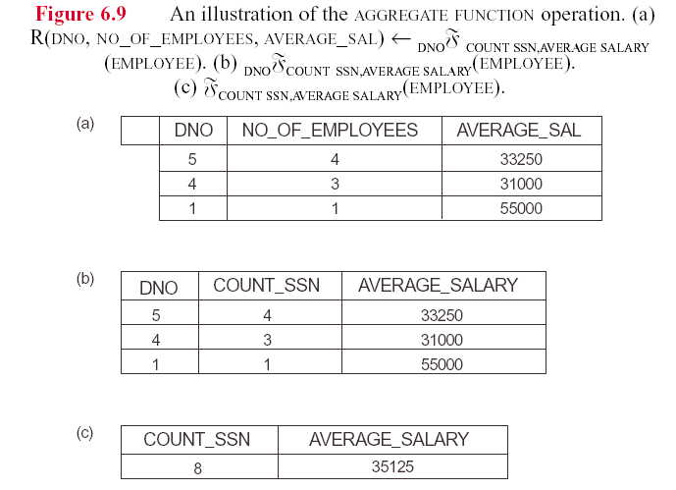

Next: various extensions of join, union, etc.

OUTER JOIN

- As defined, for EQUIJOIN or NATURAL JOIN operation, tuples in R1 or R2 that do not have matching tuples in the other relation do not appear in the result

- Some queries require all tuples in R1 (or R2 or both) to appear in the result (to make it easy to see rows of other table that are not in JOIN result)

- When no matching tuples are found, nulls are used for the missing attributes

- LEFT OUTER JOIN: R1 X R2 lets every tuple in R1 appear in the result
Ex: See textbook, Fig 6.12 RESULT, showing the LEFTOUTERJOIN, aka, LOJ, aka special textbook symbol
Query Q: List all employees and the names of the department they manage:
TEMP ← EMPLOYEE LOJ _{SSN=MGRSSN} DEPARTMENT)
RESULT ← Π _{FNAME,MINIT,LNAME, DNAME} (TEMP)
John B Smith null
Franklin T Wong Research
Are two example rows; the rows for an employee who is not a manager will have null for the DNAME column value (See Figure 6.11 below RESULT)
Oracle OUTER JOIN notation consists of specifying (+) after each table name where rows of NULL column values will appear

- RIGHT OUTER JOIN: R1 X R2 lets every tuple in R2 appear in the result

- FULL OUTER JOIN: R1 X R2 lets every tuple in R1 or R2 appear in the result (So it combines the LOJ and ROJ operators)

Outer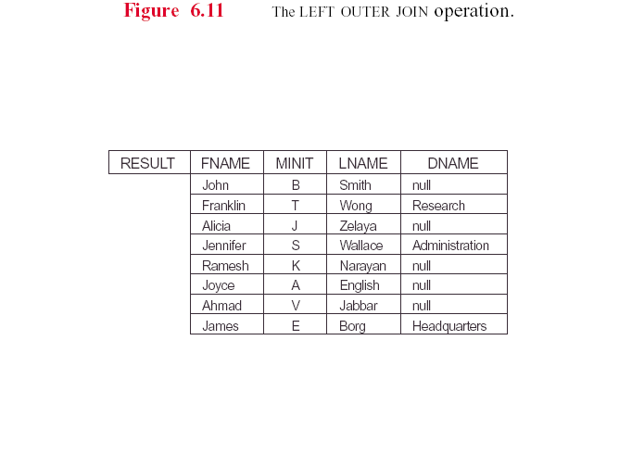

Outer Union

